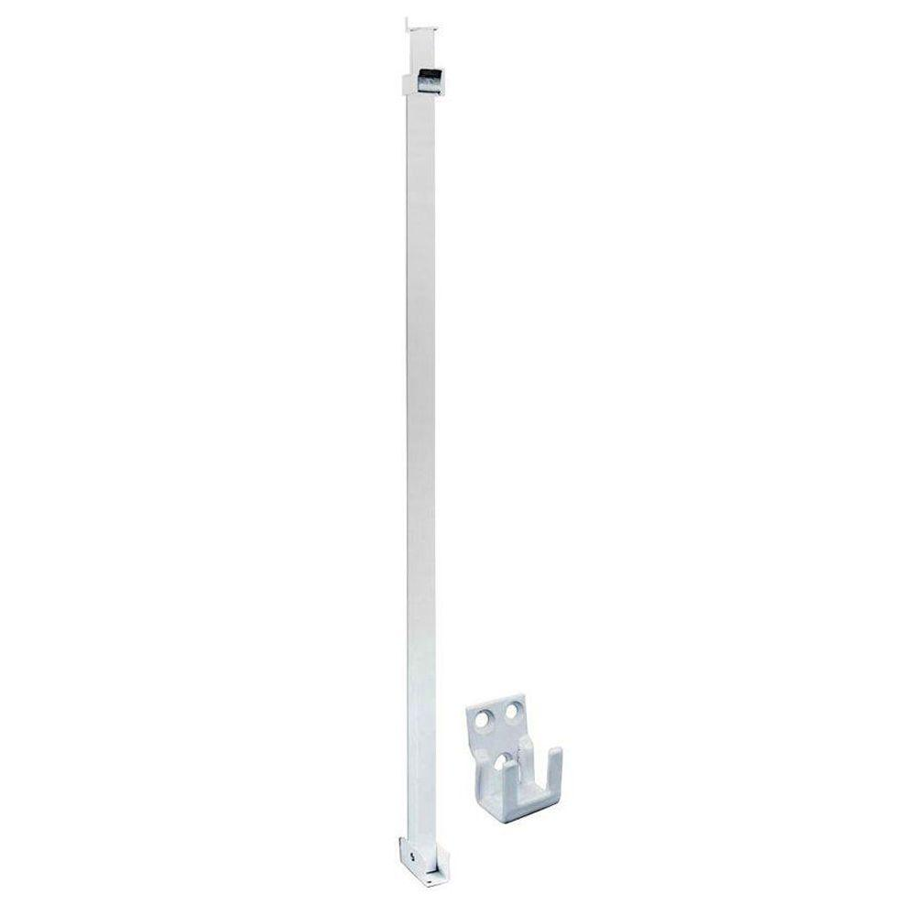
Aluminum Security Bar – remember all of our recent burglaries were through the sliding glass doors. And don’t forget to lock the gates into your patios.
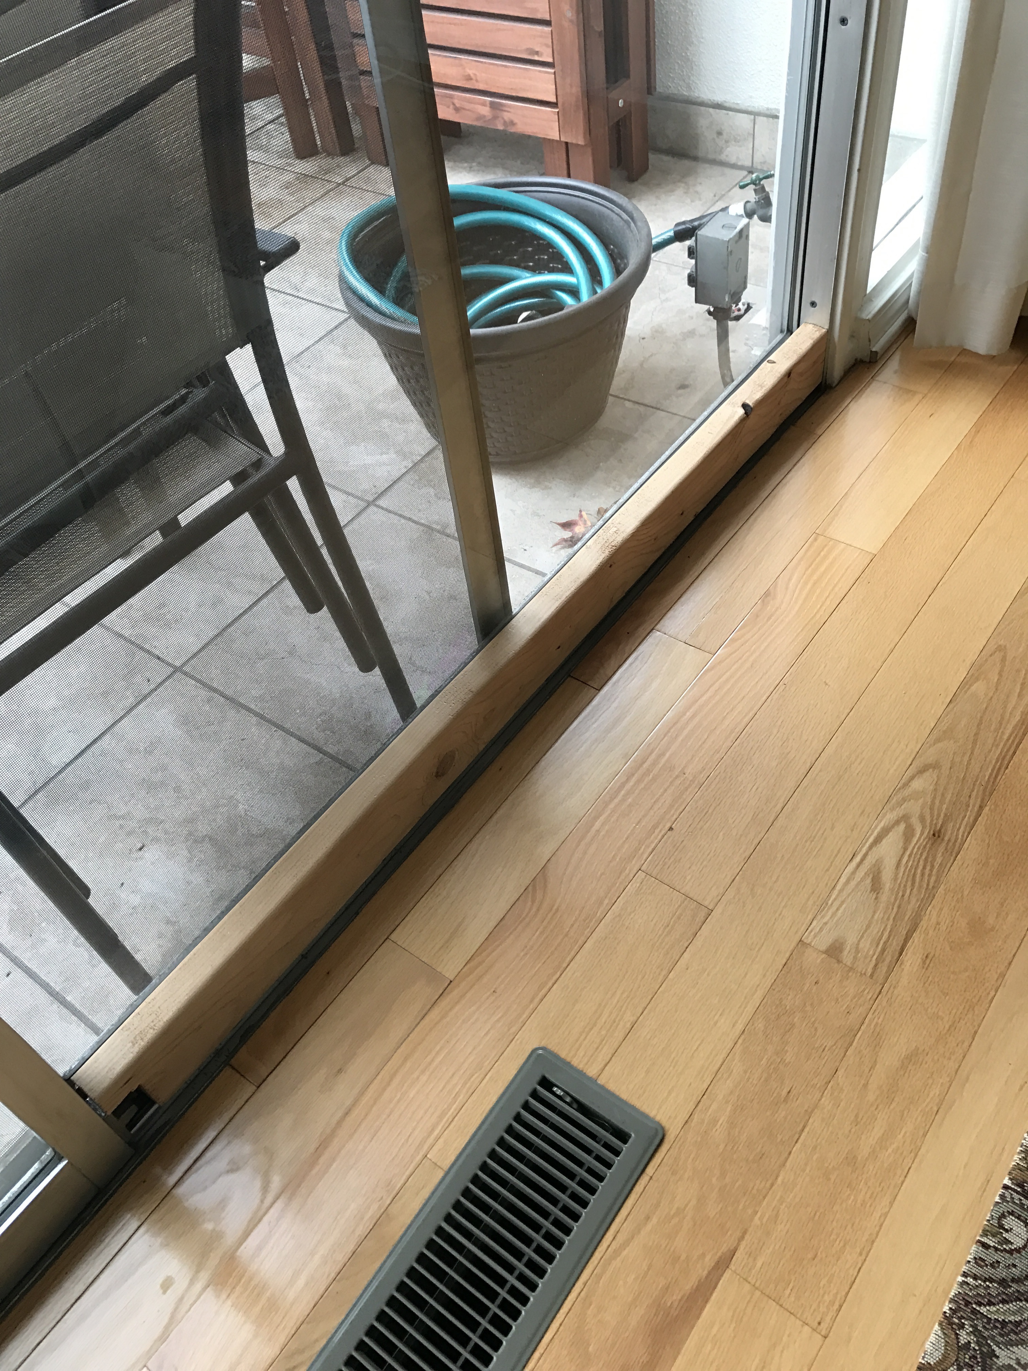

2 x 4 or aluminum bar attached higher on the door $20

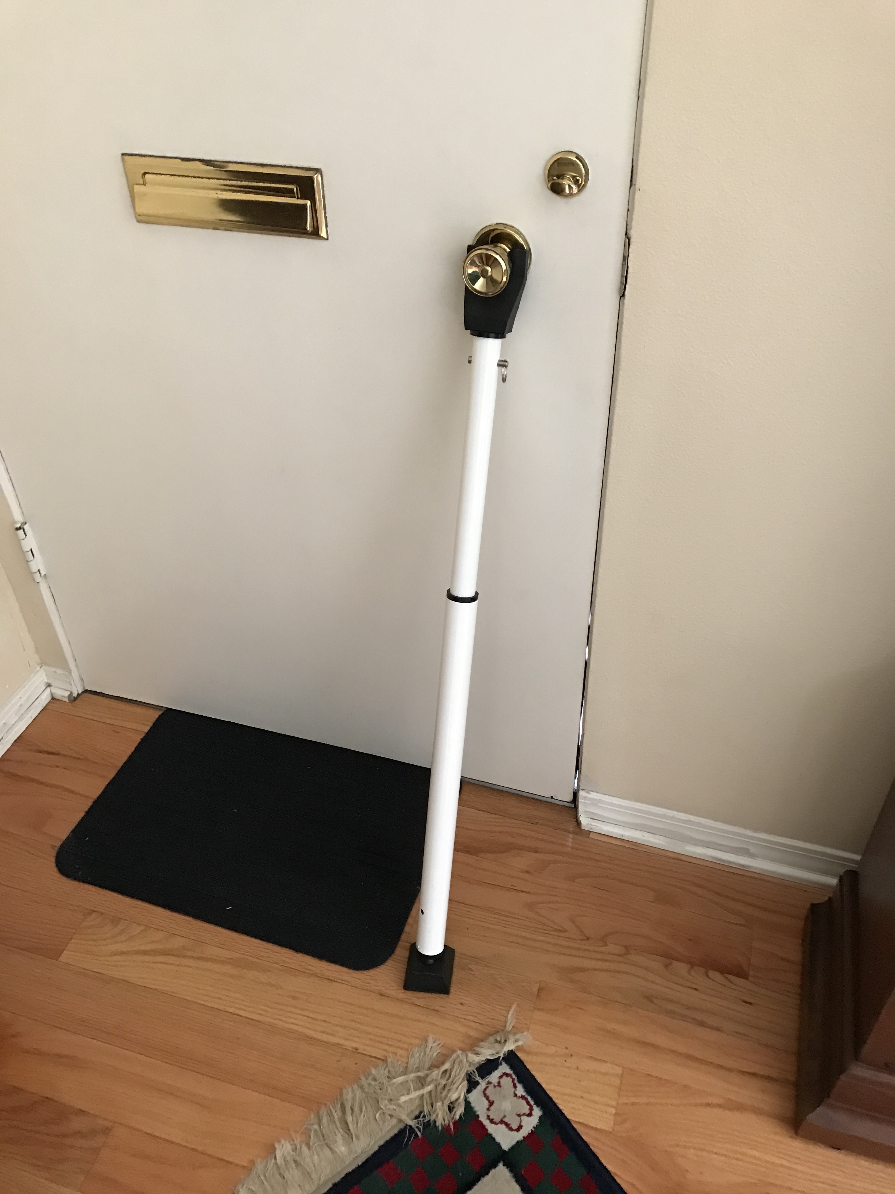

Front Door Security Bar $20
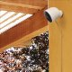

Front Door
Security Camera – Ask any member of the Board for help

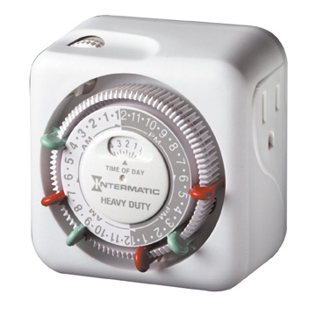
A simple light on a timer will keep your house lit up while you are away which will help to keep burglars away. Walking around the property at night it is easy to see who is not home as most of the houses are totally dark.

